How can a journey change your life?
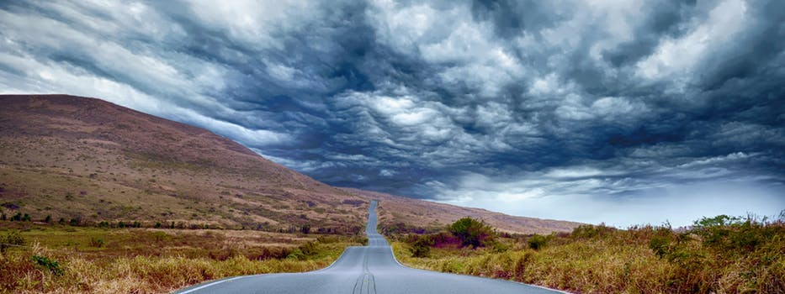

“Traveling – it leaves you speechless, then turns you into a storyteller.” – Ibn Battuta
Have you ever asked yourself "How old am I?" the question sounds pretty obvious as you would think that a quick look at your birth certificate will answer that question. But is it true?
Try to make a nice warm cup of coffee, sit quietly and do only one thing … Remember.
Remember what happened yesterday… can you remember what you ate? Who was the person that made you happy? What did you learn? How did you evolve?
Tough question, isn't it? Let's make it a little bit easier. Replace "yesterday" with "last year". Still can't find the answers?
Well, welcome aboard.

It's not just you, my friend. We are living in this endless circle of continuous efforts that, sometimes, seem useless." We buy things we don't need, with money we don't have, to impress people we don't like". And after forty or fifty years, we find our drawers full but our memories empty.
There is only one way to break this cursed circle, which is pretty simple, stop and travel.
As humans, whether you like it or not, we have to stop. Its' a scientific fact, that we aren't capable of working all the time. So if you don't choose to stop, your body will force you to stop at some point.
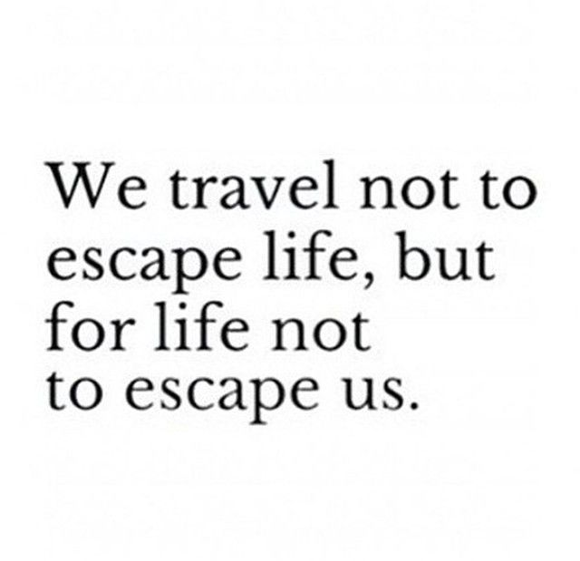
Making the decision of packing your bag for the first time can be challenging. You would start to think of all the bad things that could happen, the unexpected surprises that you may face, the strangers that you would have to deal with, the language barrier, the new culture and traditions. But in fact all of the previous reasons that might stop you from travelling are the same reasons that should encourage to take the next plane, but How?
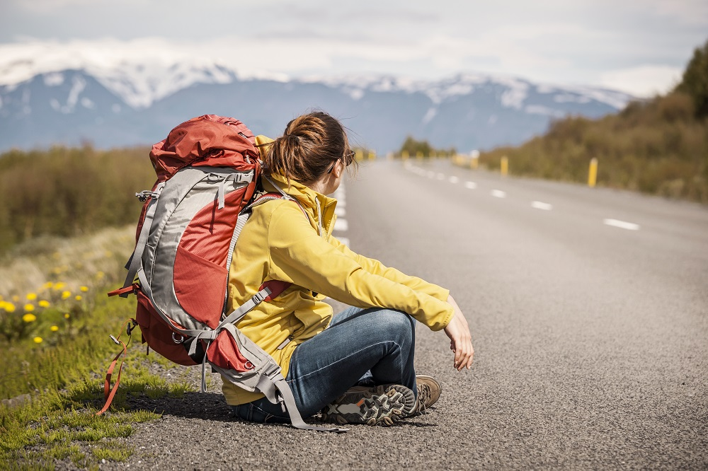
1- Surprises make you adapt.
When you face a difficult situation, whether at work or in your personal life, there are two ways to deal with it. The first way is to, simply, put your hands on your face and start to sob and regret. And the second way is to think quickly in order to find solutions to overcome the problems. When you travel, you face loads of unexpected surprises but you learn to think about alternatives. Thus, you become confident and more independent when you return home.
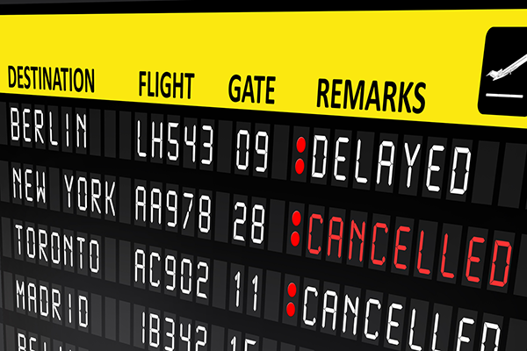

2- strangers or new friends?!
Leaving your family, friends, the whole country and going to a place where you, basically, look like an Alien can make you anxious. But, in fact, it's nothing like that. People always like the tourist. You would feel special and unique and will find yourself in need to start conversations with people you don't know in order not to stay alone, you will realize how interesting and extraordinary humans can be and how it takes a few seconds to turn a "Stranger" into "a lifetime friend" and, there is no doubt, that you will become more sociable than ever.
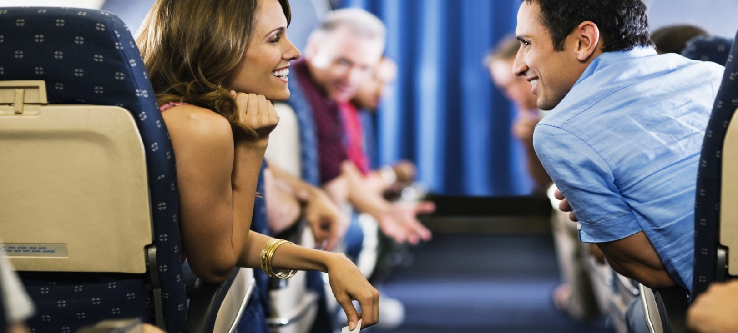
3- Time to start those Spanish lessons
Remember that beautiful latino girl that you saw and decided to learn Spanish but you never did, or that emotional French movie that made you start with the "cours de français" but you never finished it because you were overwhelmed with work or study. Well, travelling can give you the sufficient motivation to; finally, learn a new language in order to break the language barrier that you would face. The moment you return home you will find yourself a bilingual or even multilingual expert.

4-Don't trust the media, trust your eyes
Every time you turn on the T.V, you watch wars and catastrophes in a way that makes you feel that the world is on fire and that you shouldn't leave, not just your country, but even your home to buy bread from the supermarket.
When you travel, you will find that the world is a beautiful place and that most people are peaceful and friendly. You will shape your own perspective of the world and come back home to tell stories… Real stories about other cultures and traditions.

Finally, remember what Wallace Stevens said. “The most beautiful in the world is, of course, the world itself.”
Yes, the world can seem mysterious and surprising, but at the end, that's the reason why we have to pack our bags and explore it. So what are you waiting for? Choose your destination, book the ticket and explore the world.

